ELEC2230 – Solutions – Tutorial number 2

1.

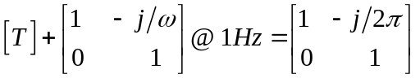

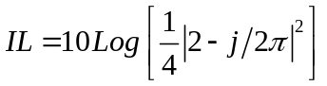

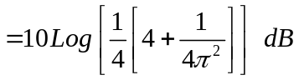

2.
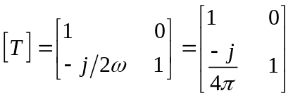

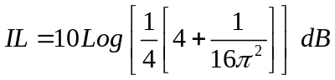

3.
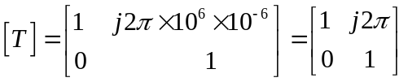

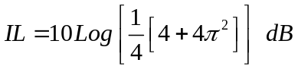

4.
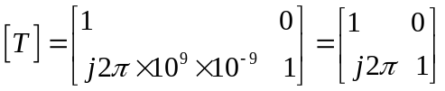

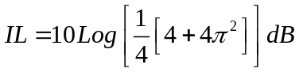

5.
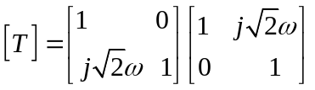

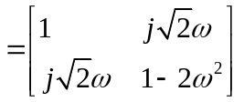

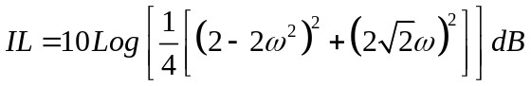

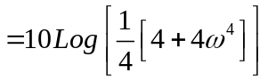

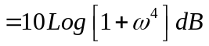

6.
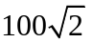

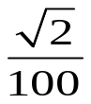


Normalise to 

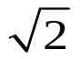


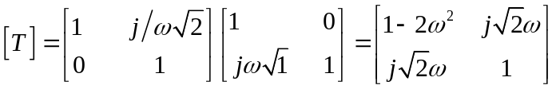

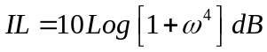

7.
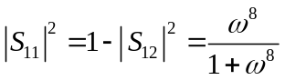

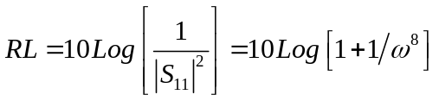

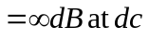

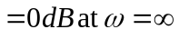

8.
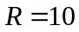



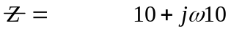

in  normalised 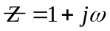

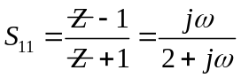

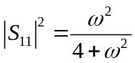

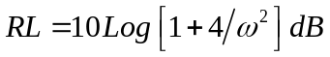

9.
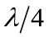


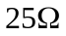

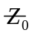

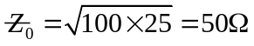



10.

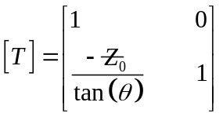

Insertion loss =

